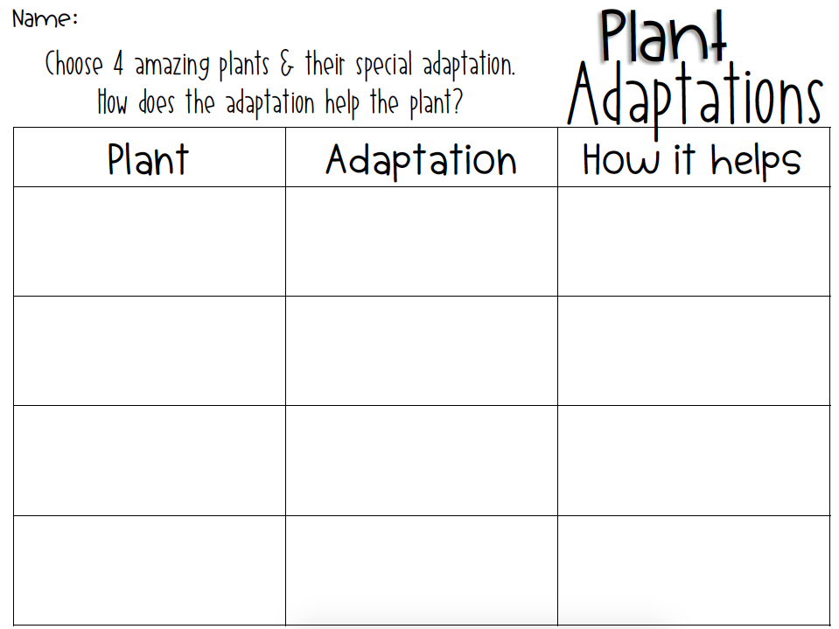

Brown Bear

Panda Bear

Polar Bear

Octopus

Animal

How it helps.

Animal

Adaptation

Listen for 4 amazing animals. Choose one of its special adaptations. How does the adaptation help the animal?