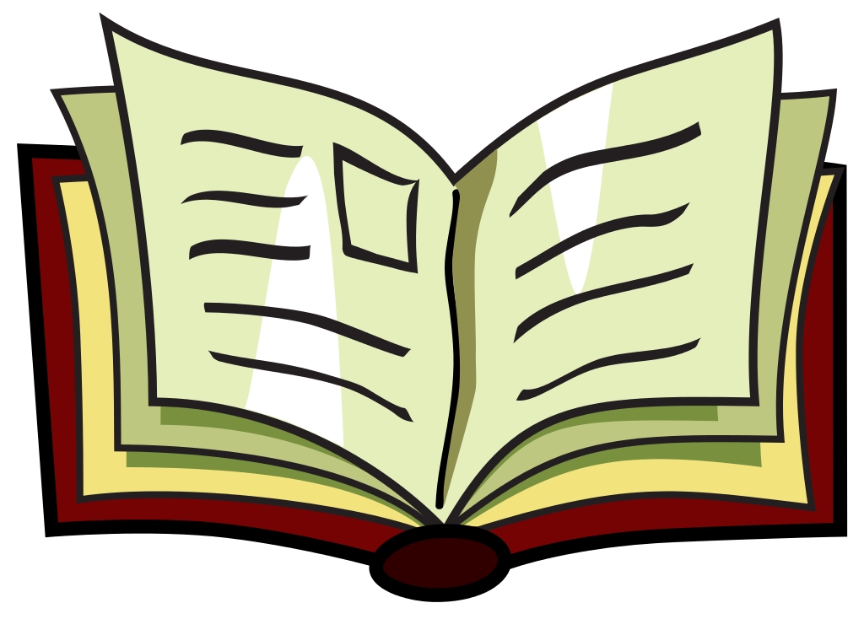
Unit 6 Week 2
This Photo by Unknown Author is licensed under CC BY-SA

Sight Words

along
became
beside
four
hello
large
notice
round
supposed
surprised

